

Sunday, September 10, 2023

Season of Creation

**10:00 a.m. Holy Eucharist BAS**

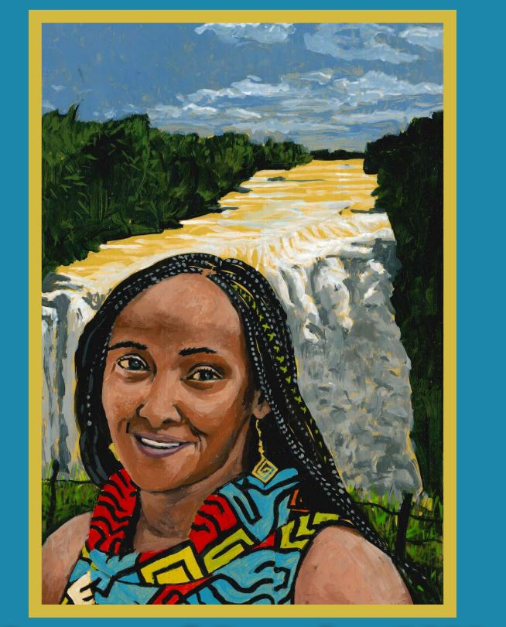

**WELCOME**

**TERRITORIAL ACKNOWEDGEMENT**

**the gathering of the community**

**OPENING HYMN** *CP # Morning Has Broken*

**Gathering:**

Divine Voice – You sing and the universe comes into

being.

Divine Breath – You breathe and all things spring to life

Divine Word – You call and creation is sustained

Divine Flesh – you are born among us Divine Spirit - you fill all that has been formed

Divine Life – you are the pulse of all that is

And so, in amazement, awe, wonder, and celebration.

We marvel at this mystery.

In you, all things live and move and have being

In all things, you live and move and express your Divine artistry. And so, we join with creation in the eternal song of worship and wonder.

**Penitence:**

If we have worshipped you as a relic from the past, a

theological concept, a religious novelty, but not as a living

God: Lord Forgive us If we have heard stories of struggle

and suffering with no intention of sharing the burden or the

pain Lord Forgive us If we have identified the misuse of

power, but failed to prophesy against it, and refused to

empower the weak: Lord Forgive us If we have sung

songs in praise of your creation, while defiling the

goodness of the earth Lord Forgive us The Lord says I will

bring my people back to me, I will love them with all my

heart. No longer am I angry with them. I will be to the

people like rain in a dry land. This is the promise of God

**Amen thanks be to God.**

*(Worship resources: World Conference on Mission and Evangelism)*

**act of praise:** Glory to God, Setting Five, Evangelical Lutheran Worship

**THE COLLECT OF THE DAY:**

Celebrant: Let us pray

**All:**  **God of the prophets you shame the strong through the weakness of love and turn upside down the wisdom of the world: may your blessing dwell with the poor and hungry, the grieving and abused; may your peaceful revolution be our joy and our reward; through Jesus Christ, the power of God. Amen**

**PROCLAMATION OF THE WORD**

**fIRST rEADING exodus** **12.1-14**

The Lord said to Moses and Aaron in the land of Egypt, “This month shall mark for you the beginning of months; it shall be the first month of the year for you. Tell the whole congregation of Israel that on the tenth of this month they are to take a lamb for each family, a lamb for each household. If a household is too small for a whole lamb, it shall join its closest neighbor in obtaining one; the lamb shall be divided in proportion to the number of people who eat of it. Your lamb shall be without blemish, a year-old male; you may take it from the sheep or from the goats. You shall keep it until the fourteenth day of this month; then the whole assembled congregation of Israel shall slaughter it at twilight. They shall take some of the blood and put it on the two doorposts and the lintel of the houses in which they eat it. They shall eat the lamb that same night; they shall eat it roasted over the fire with unleavened bread and bitter herbs. Do not eat any of it raw or boiled in water but roasted over the fire, with its head, legs, and inner organs. You shall let none of it remain until the morning; anything that remains until the morning you shall burn with fire. This is how you shall eat it: your loins girded, your sandals on your feet, and your staff in your hand, and you shall eat it hurriedly. It is the Passover of the Lord. I will pass through the land of Egypt that night, and I will strike down every firstborn in the land of Egypt, from human to animal, and on all the gods of Egypt I will execute judgments: I am the Lord. The blood shall be a sign for you on the houses where you live: when I see the blood, I will pass over you, and no plague shall destroy you when I strike the land of Egypt.

“This day shall be a day of remembrance for you. You shall celebrate it as a festival to the Lord; throughout your generations you shall observe it as a perpetual ordinance.

**Reader**: The Word of the Lord

**People**: **Thanks be to God**

**PSALM 1****49**

Hallelujah!

Sing to the Lord a new song; * **sing the praises of God in the congregation of the faithful.**

Let Israel rejoice in their maker; * **let the children of Zion be joyful in their sovereign.**

Let them praise the name of the Lord in the dance; * **let them sing praise to God with timbrel and harp.**

For the Lord takes pleasure in this people * **and adorns the poor with victory.**

Let the faithful rejoice in triumph; * **let them be joyful on their beds.**

Let the praises of God be in their throat * **and a two-edged sword in their hand;**

to wreak vengeance on the nations * **and punishment on the peoples;**

to bind their rulers in chains * **and their nobles with links of iron;**

to inflict on them the judgement decreed; * **this is glory for all God’s faithful people.**

Hallelujah!

***Gradual Hymn:*** *CP #307 When Long Before Time, verses 1,3,6*

**Gospel READING: MATTHEW** **8.15-20**

Reader: God be with you..

**People: And also with you**

Reader: The Gospel News of Jesus Christ according to Matthew

**People: Glory to you, Lord Jesus Christ**

“If your brother or sister sins against you, go and point out the fault when the two of you are alone. If you are listened to, you have regained that one. But if you are not listened to, take one or two others along with you, so that every word may be confirmed by the evidence of two or three witnesses. If that person refuses to listen to them, tell it to the church, and if the offender refuses to listen even to the church, let such a one be to you as a gentile and a tax collector. Truly I tell you, whatever you bind on earth will be bound in heaven, and whatever you loose on earth will be loosed in heaven. Again, truly I tell you, if two of you agree on earth about anything you ask, it will be done for you by my Father in heaven. For where two or three are gathered in my name, I am there among them.”

Reader: The Gospel of Christ

**People:** **Praise to you Lord Jesus Christ**

**talk by revEREND** **DENISE DOERKSEN**

**affirmation of faith**

Celebrant: Let us affirm our faith

**All: O God, source of all being, goal of our longing, We believe and trust in you.**

**The whole earth is alive with your glory, and all that has life is sustained by you. We commit ourselves to cherish your world, and to seek your face.**

**O God, embodied in a human life, we believe and trust in you.**

**Jesus, our brother, born of the woman Mary, you confronted the proud and powerful, and welcomed as your friends those of no account.**

**You laboured with us upon the cross and have brought to us the hope of resurrection.**

**We commit ourselves to struggle against evil, and to choose life.**

**O God, life-giving Spirit of healing, comfort, integrity and truth, we believe and trust in you. Warm-winged Spirit, brooding over creation, rushing wind and Pentecostal fire, we commit ourselves to work with you in renewing our world.**

*(Lynn Uzan The Parish of Wilmot, Diocese of N.S. and P.E.I)*

**Prayers of the People**

**THE PEACE**

Celebrant: The peace of the Lord be always with you.

**People: And also with you.**

**Offertory Hymn**  *Here I Am Lord*

I, the Lord of sea and sky,

I have heard my people cry.

All who dwell in dark and sin

My hand will save.

I who made the stars of night,

I will make their darkness bright.

Who will bear my light to them? Whom shall I send?

**Chorus:**

Here I am, Lord. Is it I, Lord?

I have heard you calling in the night.

I will go, Lord, if you lead me,

I will hold your people in my heart.

I, the Lord of snow and rain,

I have borne my peoples pain.

I have wept for love of them –

They turn away.

I will break their hearts of stone,

Give them hearts for love alone.

I will speak my word to them. Whom shall I send?

**Chorus**

I, the Lord of wind and flame,

I will tend the poor and lame

I will set a feast for them –

My hand will save.

Finest bread I will provide

Till their hearts be satisfied.

I will give my life to them. Whom shall I send?

**Chorus**

**the celebration of the eucharist**

**The Prayer over the Gifts**

Celebrant: Let us Pray

**All: Great and holy God, accept our offering of labour and love. May we bring you true and spiritual worship and be one with you. We ask this in the name of Jesus Christ the Lord. Amen**

**the great thanksgiving**

Celebrant: The Lord be with you.

**People: And also with you.**

Celebrant Lift up your hearts.

**People: We lift them up unto the Lord.**

Celebrant: Let us give thanks to the Lord our God.

**People: It is right to give our thanks and praise.**

Celebrant: We thank and praise you almighty Father. In wisdom you guide the course of the world and cherish us with all tender care. We thank you that we can come together around this table in the name of Jesus your Son, the first born of all creation. In him all things were created, visible and invisible, and all things hold together in him.

We thank you that you have sent your Holy Spirit to make of us a new community of faith to serve you within your creation.

And now we give you thanks because you have given the earth into our care, and call us to praise you day by day for the marvels of your creation. And so with the wonders of creation and the songs of praise of all your creatures both in heaven and on earth we join in one great act of awe and adoration:

**All: Holy, holy, holy Lord…God,**

**God of might and power; holy is the Lord**

**Holy, holy, holy, holy Lord God,**

**God of might and power, holy is the Lord**

**Hosanna in the highest, hosanna here on earth,**

**Blest is he who comes in the name of the Lord.**

**Hosanna in the highest, hosanna here on earth,**

**Blest is he who comes in the name of the Lord.**

Celebrant: God of all creation, send your Spirit upon the goodness of the earth, and upon these gifts of bread and wine, that in them we may recognize and receive the fullness of the Risen Christ: bread broken and wine poured, Body given, and Blood shed.

On the night he sat at table with his disciples and with them recalled the wonder of your creation and the wonder of your covenant with your chosen people, He took bread, gave you thanks, blessed it and broke it, saying:

Take this all of you and eat it. This is my Body, which will be given up for you. In the same way he took the cup and giving you thanks and praise, He gave the cup to his disciples and said: Take this all of you and drink from it, this is the cup of my Blood, the Blood of the new and everlasting covenant. It will be shed for you and for all so that sins may be forgiven. Do this in memory of me.

So we proclaim the mystery of faith

**Christ has died**

**Christ is risen**

**Christ will come again**

As we remember the death and resurrection of our Lord Jesus Christ, we celebrate the goodness of the earth, our companionship in this world and the sharing of all skills and arts that enrich our lives. We share the cup of our humanity matured over the unnumbered centuries of the long struggle that has gone into making of this world; our living and dying, our fears and our hopes.

Together with those who have drawn sustenance from this soil, those with whom we share it, and those to whom we pass it on, we share this bread and raise this cup in fulfilment of the Lord’s command: through him, with him, in him in the unity of the Holy Spirit, all glory and honour is yours, Almighty Father, forever and ever

**All: Amen.**

**THE LORD’S PRAYER**

Celebrant: As our Saviour taught us, let us pray,

**All: Our Father in heaven. Hallow’d be your name. Your kingdom come, your will be done on earth as in Heaven. Give us today our daily bread: forgive us our sins as we forgive those who sin against us. Save us from the time of trial, and deliver us from evil. For the kingdom, the power, and the glory are yours; Now and forever. Amen.**

*(Ecumenical English Version) Music by Gordon Light*

**THE BREAKING OF THE BREAD**

Celebrant: “I am the bread of life,” says the Lord. “Whoever comes to me will never be hungry; whoever believes in me will never thirst.”

**All: Taste and see that the Lord is good; happy are they who trust in him!**

**THE COMMUNION**

*Please Note: You are welcome to drink from the common cup, but if you do not want to, just touch the cup. You must not dip the bread into the cup.: We have gluten free wafers and will gladly extend the platter to you for you to take one from it. Please just let us know if you need one.*

**PRAYER AFTER COMMUNION**

Celebrant: Let us pray

**All: Father, your word and sacrament give us food and life. May we who have shared in holy things bear fruit to your honour and glory, in the name of Jesus Christ the Lord.**

**Sending Out*:***

Creator God, you have accepted us as your children as we have been adopted by your Eldest Son, Jesus Christ. You have fed us with the sacred food in the Sacrament of Christ’s Body and Blood. Send us into the world in peace, carried by your Spirit, so we might serve all we meet as holy relatives. Make us strong and brave to love and serve you with happiness and peace devoted to you through Jesus Christ our Savior. **Amen**.

*(Wintertalk Rev Brad Haupf)*

**Closing Hymn*:*** *CP #355 All Creatures of God and King, verses 1-4*

|  |
| --- |
| **September Outreach** |
| Sidney Food Bank |
| **Flowers on the Altar** |
| The flowers are to the glory of God in memoryof my parents  **Ron and Janet Billinghurst** |
| **Notices** |
| * Contact givings@holytrinityns.org to sign up for automatic monthly withdrawal of your contribution. *(Forms re available at the back of the church).* |
| |  |  |  |  |  |  |  |  |  |  |  |  |  |  |  |  |  |  |  |  | | --- | --- | --- | --- | --- | --- | --- | --- | --- | --- | --- | --- | --- | --- | --- | --- | --- | --- | --- | --- | | C:\Users\janet\Desktop\HOLY TRINITY\Holy Trinity Pictures\Holy Trinity CMYK logo North Saanich RESIZED.png1319 Mills Road, North Saanich V8L 5T2  Incumbent: Rev Denise Doerksen  Pastoral Emergencies: 250-818-6190  **Wardens**: Debra Drury and Penny Donaldson  Parish Coordinator: Laura Canales  250-656-3223  admin@holytrinityns.org l www.holytrinityns.org  Office Hours: Monday, Tuesday and Thursday  9AM - 2PM | |  |  | | --- | --- | | ***Presider*** | *Rev. Denise Doerksen* | | ***Organist*** | *Joanne Lambert* | | ***Sidespeople*** | *Lorne Seier* | | ***Reader*** | *Diana Chown* | | ***Prayers*** | *Pat Dowdall* | | ***Bells*** | *Scott Weston* | | ***Altar*** | *Robin Lake/Penny Donaldson* | | ***Counter*** | *Debra Drury* | | ***Chalice*** | *Debra Drury* | | |